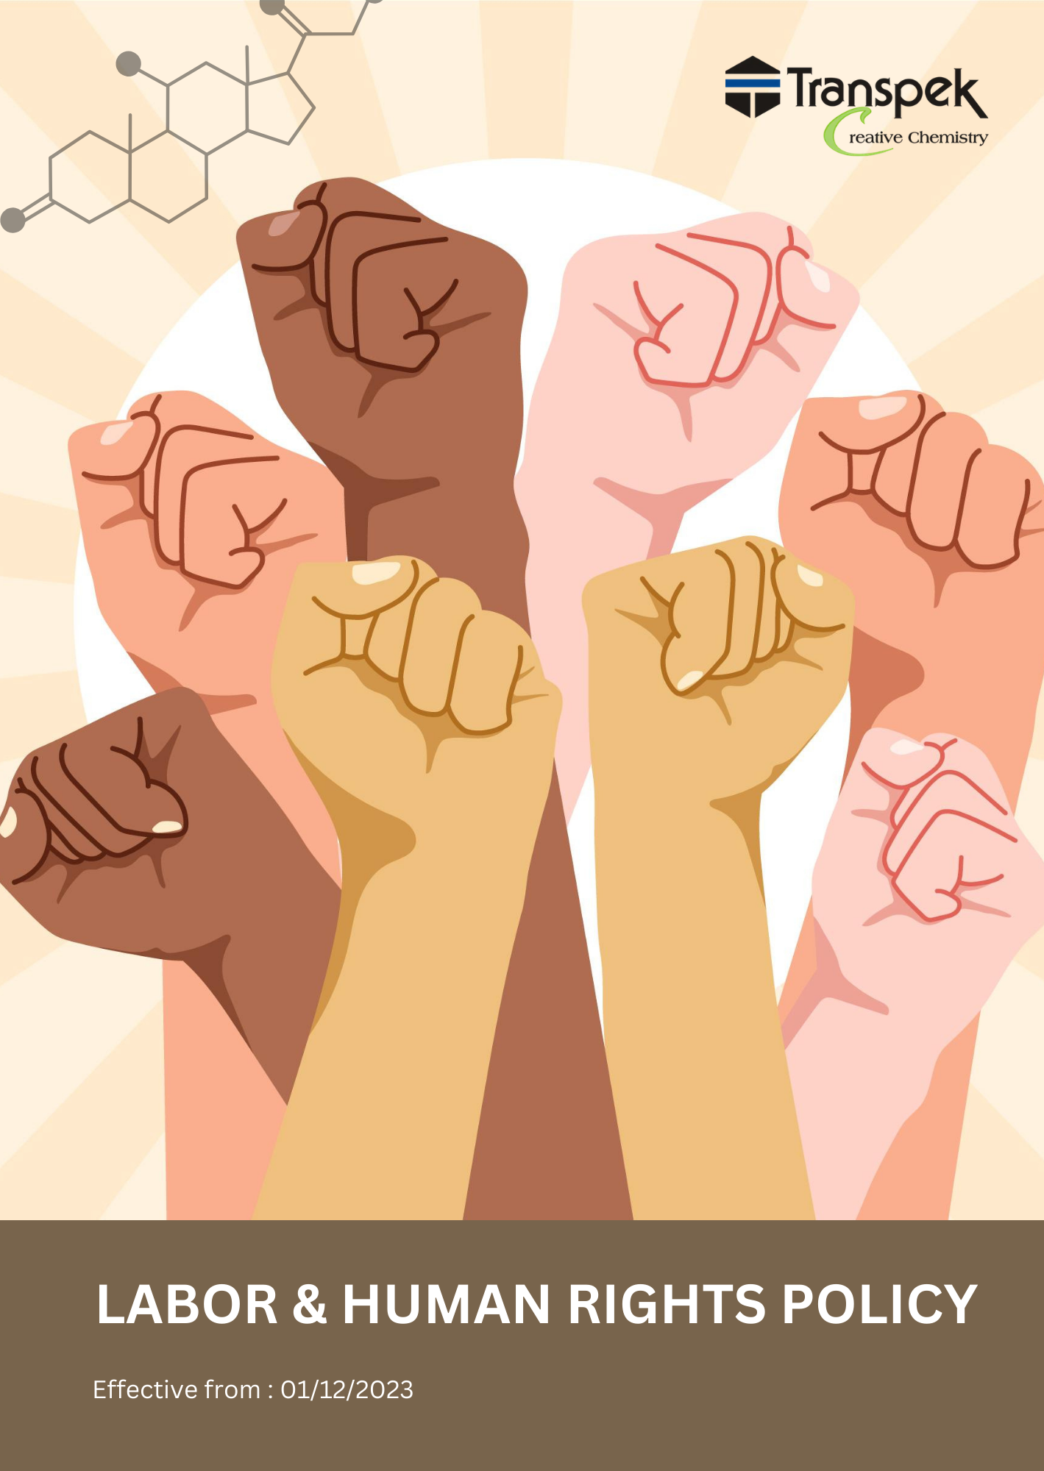

INDEX

INTRODUCTION 3
SCOPE 3
POLICY STATEMENT 3
OBJECTIVES 3
KEY FOCUS AREA 4
QUALITATIVE TARGETS 6
QUNTITATIVE TARGETS 8
RESPONSIBILITIES 10
REPORTING 12
GOVERNANCE FOR LABOUR AND HUMAN RIGHTS POLICY 13
COVERED SDGS 14
REVIEW MECHANISM 14
EMPLOYEE ACKNOWLEDGMENT FORM: LABOUR AND HUMAN RIGHTS POLICY 15

INTRODUCTION
At Transpek Industry Limited, we understand the significance of fostering a workplace rooted in fairness, respect, and dignity for all employees. As a leading player in the chemical industry, our operations span multiple sectors including pharmaceuticals, agrochemicals, and polymers, and we are committed to adhering to the highest standards of Labour and human rights.
Our responsibility extends beyond just meeting legal and regulatory obligations. We aim to create an inclusive work environment, promote the well-being of our employees, and ensure that labour rights are respected throughout our supply chain. This policy provides a framework that guides our practices and decisions, aligning with international labour standards and human rights principles.

SCOPE
This Labour & Human Rights Policy applies to all employees and management of Transpek Industry Limited. Our policy is relevant across all geographic locations and is applicable to every department involved in the manufacturing and distribution of our chemical products.
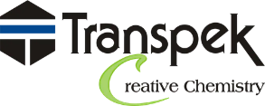 | Transpek Industry Limited
 | 4th Floor, Lilleria 1038 Gotri-Sevasi Road 390021 Vadodara, Gujarat India
 | At & Post: Ekalbara, Taluka: Padra, Dist.: Vadodara, 391440 Gujarat India
 | https://transpek.com/

POLICY STATEMENT
At Transpek Industry Limited, we commit to:
- Upholding Labour Standards: We ensure that our employees are provided with fair wages, safe working conditions, and opportunities for professional growth.
- Respecting Human Rights: We reject child and forced Labour in any form and ensure ethical treatment across all our business operations, promoting the welfare of workers and communities.
- Ensuring Inclusivity: We value diversity and are committed to fostering an environment where employees are treated equally regardless of race, gender, age, religion, or any other characteristic.

OBJECTIVES
- Improve Workplace Safety: Implement and maintain safety programs, audits, and risk assessments to minimize hazards.
- Ensure Proper PPE Use: Provide necessary PPE and train employees to prevent accidents.
- Promote Employee Well-Being: Offer health and wellness programs addressing mental and physical fitness.
- Foster Safe Work Conditions: Provide fair wages, benefits, and flexible work options for work-life balance.
- Support Collective Bargaining: Uphold employee rights for unionization and transparent communication.
- Promote Fair Labour Practices: Ensure employees receive fair wages, safe working conditions, and opportunities for skill development and career growth.
- Prevent Child and Forced Labour: Strictly prohibit child labour, forced labour, or any unethical practices in all business operations.
- Commit to Ethical Business Conduct: Support the welfare of workers and the broader community through ethical, responsible decision-making.

KEY FOCUS AREA
Employee Health & Safety: -
- Workplace Safety Programs: We are dedicated to implementing comprehensive safety programs to minimize risks associated with chemical handling and machinery operation. This includes conducting mandatory risk assessments, performing regular safety audits, and adhering to international safety standards.
- Personal Protective Equipment (PPE): We prioritize ensuring that all employees are provided with the necessary PPE and are well-trained in its correct usage to prevent accidents and injuries.
- Health & Wellness Programs: We emphasize promoting employee well-being through wellness initiatives focused on mental health support, stress management, and physical fitness. This includes offering counselling services, workshops on stress management, and fitness programs.
- Training & Awareness: We are committed to providing regular training on safety protocols, emergency procedures, and first aid, ensuring employees are equipped to handle workplace hazards effectively.

Working Conditions: -
- Fair Wages & Benefits: We strive to ensure that all employees receive fair compensation that aligns with industry standards, reflects the cost of living, and complies with legal requirements. We also offer benefits such as health insurance, paid time off, and retirement plans.
- Work-Life Balance: We focus on offering flexible work arrangements, allowing employees to maintain a healthy balance between personal and professional responsibilities. This includes flexible hours, remote work options where feasible, and ensuring employees' right to disconnect outside work hours.
- Two-Way Communication: We encourage open dialogue between employees and management regarding working conditions, ensuring that employees can freely express concerns, suggestions, or grievances through structured feedback mechanisms.
Labour Relations: -
- Employee Representation & Collective Bargaining: We respect employees' rights to form and join trade unions and participate in collective bargaining. Clear communication channels are in place for employees to raise concerns or negotiate working conditions.
- Conflict Resolution: We ensure that clear mechanisms are available for resolving conflicts related to wages, benefits, or other workplace conditions, allowing employees to report concerns without fear of retaliation.
- Labour Rights Training: We regularly conduct training programs to educate both management and employees on labour rights, best practices in labour relations, and conflict resolution strategies.
Career Management: -
- Equal Opportunity Employment: We are committed to ensuring that our recruitment processes are transparent and inclusive, offering equal opportunities for all individuals, regardless of gender, race, ethnicity, disability, or other protected characteristics.
- Training & Development: We support ongoing professional development by offering workshops, skill-enhancement programs, and mentorship opportunities, helping employees advance in their careers.
- Promotion Transparency: We maintain a focus on ensuring promotions are based on merit, with clear evaluation criteria used to assess employee performance and potential. Employees are regularly informed about available opportunities for career advancement.
Child & Forced Labour: -
- Training & Monitoring: We conduct training for employees and suppliers to recognize and report instances of child or forced labour, with regular audits ensuring compliance.
- Legal Compliance: We strictly adhere to national and international laws concerning child and forced labour, ensuring that all operations meet these legal standards.
Diversity, Equity & Inclusion (DEI): -
- Zero Tolerance for Discrimination: We uphold a zero-tolerance policy for any form of discrimination or harassment, including physical, psychological, or verbal abuse, and ensure that clear policies are in place to foster a respectful workplace.
- Diverse Hiring Practices: We actively promote diversity in our hiring processes, ensuring that candidate pools reflect a broad range of backgrounds and experiences.
External Stakeholder Human Rights: -
- Respect for Land & Property Rights: In area where we operate, we respect the land and property rights of local communities, ensuring that our operations do not infringe on these rights.
- Stakeholder Engagement: We actively engage with external stakeholders such as community groups, labour unions, and suppliers to foster dialogue on human rights issues and ensure compliance with local & international human rights standards.

QUALITATIVE TARGETS
Employee Health & Safety:
- Establish a culture of safety awareness with regular safety meetings and discussions across all levels of the organization.
- Introduce mental health awareness initiatives to support employees facing psychological challenges.
- Develop an employee health monitoring system to track workplace incidents and identify trends, enabling the company to take proactive measures to prevent accidents and health issues.
Working Conditions:
- Ensure transparent communication channels for discussing work conditions, focusing on timely responses to employee concerns.
- Promote flexible work arrangements to support work-life balance.
Labour Relations:
- Foster labour relations by ensuring regular dialogue between management and employees on working conditions and rights.
- Provide training programs on labour rights and relations, ensuring employees are informed and empowered.
- Implemented a structured grievance redressal mechanism to ensure that any workplace disputes or concerns are addressed promptly and fairly.
Career management:
- Develop and implement individualized career progression plans for employees, focusing on enhancing their skills and aligning their growth with the company's strategic objectives in the chemical manufacturing sector.
- Introduce comprehensive training modules, workshops, and certifications tailored to industry-specific needs, such as chemical safety management, innovation in chemical processes, and operational excellence.
- Establish a transparent system for internal job postings and promotions, ensuring fair access to career advancement opportunities across all levels of the organization.
Child & Forced Labour:
- Conduct regular supplier audits and provide training to prevent child and forced Labour throughout our supply chain.
- Collaborate with industry groups and NGOs to strengthen efforts in identifying and eliminating child and forced labour practices in high-risk areas.

Diversity, Equity & Inclusion (DEI):
- Implement DEI programs that promote a diverse and inclusive culture where all employees feel valued and respected.
- Increase representation of women in leadership roles through targeted mentorship and development programs.
- Establish DEI performance metrics to regularly assess progress on diversity goals, ensuring that leadership accountability is in place.
External Stakeholder Human Rights:
- Respect for Local Communities: Engage with local communities to understand their concerns, ensuring that our operations respect local customs, land, and property rights.
- Supplier Code of Conduct Compliance: Conduct regular audits and ensure that all suppliers and partners comply with Transpek’s Supplier Code of Conduct, emphasizing human rights protection throughout the supply chain.
- Grievance Mechanisms for External Stakeholders: Develop and maintain accessible grievance mechanisms for external stakeholders, ensuring they can report human rights concerns confidentially and securely.

QUNTITATIVE TARGETS
Employee Health & Safety:
- Achieve a 20% reduction in workplace accidents related to hazardous substances and chemical handling by FY 2029-30, compared to the baseline year of FY 2022-23.
- 100% employees will be covered under mental health, work related stress and psychological support program and counselling services by FY 2029-30, compared to the baseline year of FY 2022-23.
- Improve PPE compliance by 30% across all departments by FY 2029-30, ensuring all employees are equipped and trained on the correct use of protective gear.
- Increase employee participation in health and safety training programs by 25% by the end of FY 2029-30, compared to participation levels in FY 2022-23, with a focus on safe chemical handling, emergency procedures, and risk management.

Working Conditions:
- Enhance employee benefits by 10% by FY 2029-30, compared to the FY 2022-23 baseline, ensuring competitive healthcare, retirement plans, and wellness programs that support employee security and well-being.
- Maintain 100% coverage of regular two-way communication channels on working conditions every year.
- Achieve 90% employee participation in training programs focused on labour rights and workplace policies by FY 2029-30, promoting understanding of worker rights and fostering a supportive work environment.
Labour Relations:
- Achieve a 20% increase in union engagement and structured labour relations by FY 2029-30, promoting better dialogue between management and labour representatives compared to FY 2022-23 levels.
- Ensure 100% employee involvement in decision-making processes related to workplace policies by FY 2029-30, fostering greater inclusivity and Collaboration.
- Increase the frequency of social dialogue by 20% by FY 2029-30, ensuring regular discussions between employees and management to resolve any workplace concerns.
Career Management:
- Increase the representation of underrepresented groups in recruitment by 10% by FY 2029-30, compared to FY 2022-23 levels, ensuring greater diversity in hiring practices across all departments.
- Increase participation in career development programs by 15% by FY 2029-30, compared to FY 2022-23, aligning employees’ skills with evolving industry needs and personal growth opportunities.
- Enhance performance appraisal accuracy by 15% through improved methodologies and transparent criteria by FY 2029-30, ensuring a fair and consistent evaluation process compared to FY 2022-23.
Child & Forced Labour:
- Maintain 100% compliances to child and forced labour regulations.
- Ensure a 100% recruitment of a person with age above 18 years
- Impart training to 100% employees on policy on Child and Forced labour by FY 2029-30
Diversity, Equity & Inclusion (DEI):
- Ensure Zero incidents of discrimination and abuse by through enhanced awareness, training, and strict anti-discrimination policies.
- Ensure 100% employee participation in DEI training programs by FY 2029-30, fostering a more inclusive and equitable work environment, compared to FY 2022-23 participation levels.
External Stakeholder Human Rights:
- Ensure Zero grievances related to land and property disputes through transparent resolution mechanisms and stakeholder engagement.
- Reduce workplace incidents by 20% by FY 2029-30 through comprehensive safety measures and training for employees and external stakeholders, compared to the incident rates in FY 2022-23.
- Increase employee satisfaction with working conditions by 10% by FY 2029-30, based on internal surveys, compared to satisfaction levels in FY 2022-23, focusing on improving communication, safety, and inclusivity.

RESPONSIBILITIES
Managing Director:
- Lead the overall strategy and review for labour and human rights policies.
- Ensure company policies align with international labour standards and human rights principles.
- Approve major initiatives related to employee welfare, diversity, and compliance with labour laws.
- Regularly review and monitor the effectiveness of policies related to labour relations, health, safety, and human rights compliance.
Human Resources Manager:
- Oversee the development and implementation of the Labour & Human Rights Policy.
- Ensure recruitment and management practices align with diversity, equity, and inclusion (DEI) goals.
- Develop training programs on labour rights, safety protocols, and DEI for all employees and management.
- Manage grievance redressal mechanisms and ensure timely resolution of issues related to working conditions and discrimination. Monitors progress towards achieving set environmental targets and ensures accountability.
Supply Chain Manager:
- Ensure suppliers adhere to the Labour & Human Rights Policy, including prohibitions on child and forced labour.
- Conduct regular audits of suppliers to verify compliance with labour standards.
- Collaborate with industry groups and NGOs to identify and eliminate unethical labour practices.
- Implement and monitor performance metrics related to supplier labour practices.
Diversity, Equity & Inclusion (DEI) Manager:
- Lead the design and execution of DEI programs to promote a diverse and inclusive work environment.
- Set measurable diversity goals, such as increasing representation in leadership roles by FY 2029-30.
- Develop and deliver training programs on DEI topics for all employees.
- Regularly assess and report on the company's progress toward DEI goals.
Labour Relations Manager:
- Foster communication between employees and management on labour relations issues.
- Manage the collective bargaining process and act as a liaison during negotiations.
- Implement grievance redressal mechanisms for labour disputes and ensure fair resolutions.
- Increase union engagement by promoting regular meetings and dialogue sessions.
Training & Development Manager:
- Develop and implement career development and training programs focused on Labour rights and safety.
- Ensure employee training participation increases by 10% by FY 2029-30.
- Facilitate equal opportunity training to ensure diversity in promotions and recruitment.
- Monitor the effectiveness of training programs and update content based on feedback.
Employee Responsibilities:
- Comply with all labour and human rights policies, reporting any violations or concerns.
- Actively participate in training programs related to workplace safety and rights.
- Engage in open communication with management regarding working conditions and any grievances.
- Contribute to a positive workplace culture by promoting inclusivity, respect, and Collaboration among colleagues.

REPORTING
Regulatory Compliance Reporting:
- Ensure the timely submission of compliance reports to regulatory authorities, outlining adherence to environmental regulations and detailing any incidents that may have occurred.
- Keep thorough records of environmental audits, inspections, and assessments to demonstrate compliance with all applicable laws and regulations.
Engagement with Stakeholders:
- Provide clear and transparent updates to stakeholders—including employees, customers, and local communities—on environmental initiatives and progress.
- Use a variety of communication channels, such as newsletters, social media, and the company website, to share achievements and address any environmental concerns raised by stakeholders.
Internal Reporting Systems:
- Create dedicated internal channels for employees to report environmental concerns, incidents, or suggestions for improvement.
- Foster a culture of accountability by ensuring that all reports are reviewed promptly and addressed effectively.
Training and Awareness Programs:
- Develop training programs to enhance employees' understanding of environmental regulations and compliance obligations.
- Promote awareness of environmental issues and best practices through workshops, seminars, and informational materials.
Risk Assessment and Management:
- Implement regular risk assessments to identify potential environmental impacts and compliance risks associated with business operations.
- Develop and maintain a risk management plan that outlines strategies for mitigating identified risks and ensuring compliance with environmental regulations.
Sustainability Initiatives:
- Establish and promote sustainability initiatives aimed at reducing the organization's environmental footprint.
- Monitor and report on the progress of sustainability goals, including energy conservation, waste reduction, and resource management.

GOVERNANCE FOR LABOUR AND HUMAN RIGHTS POLICY
To ensure effective governance of the Labour and Human Rights Policy, a dedicated Labour Rights Oversight Committee (LROC) will be established. The LROC will oversee compliance with labour laws, monitor workplace practices, and address any human rights concerns. Regular meetings will be held to evaluate progress, review incident reports, and recommend improvements.
The committee will comprise representatives from key departments, including human resources, legal, and operations, and will report directly to senior management to ensure alignment with organizational objectives.
Additionally, a comprehensive documentation and reporting framework will be maintained to track compliance activities, employee feedback, and stakeholder communications. This governance structure will ensure accountability and promote a proactive approach to labour and human rights management within the organization.

COVERED SDGS
 |  |  |  |  |  | 

REVIEW MECHANISM
The Managing Director will conduct an annual review of the Labour & Human Rights Policy, focusing on key performance indicators, employee feedback, and supplier audits. This process will involve data analysis, stakeholder consultation, and identification of challenges. The findings will be compiled into a report, with actionable recommendations presented to the Board of Directors. An action plan will be developed for implementation, with follow-ups scheduled to monitor progress throughout the year.

REVISION HISTORY
Revision No. | Revision Date | Description of Change
00 | 01-01-2023 | Initial release of the Labour & Human Rights Policy
01 | 01-04-2024 | Added the sections “Quantitative Targets” and “Qualitative Targets” and incorporated relevant SDGs
02 | 01-04-2025 | Revised sustainability targets with updated achievement timelines and added a formal Revision History table
03 | 01-04-2026 | Conducted the annual review of the Labour & Human Rights Policy – No changes required

(Signature)
Approved By:
Designations:
Last Review Date: 01-04-2026 Next Review Date: 01-04-2027

EMPLOYEE ACKNOWLEDGMENT FORM: LABOUR AND HUMAN RIGHTS POLICY
I, acknowledge that I have received and read the Labour & Human Rights Policy of Transpek Industry Limited. I understand the importance of maintaining a workplace founded on fairness, respect, and dignity for all employees. I am aware of my responsibilities to comply with this policy, including adhering to safety protocols, promoting inclusivity, and reporting any violations or concerns regarding labour rights and working conditions.
I recognize that the company is committed to providing a safe and healthy work environment, fair wages, and opportunities for professional growth. I understand that any form of discrimination, harassment, child labour, or forced labour will not be tolerated.
By signing this acknowledgment, I affirm my commitment to uphold the principles outlined in the Labour & Human Rights Policy and contribute positively to our workplace culture.

Employee Name: ______________________

Date: _______________

Employee Signature: ____________________

